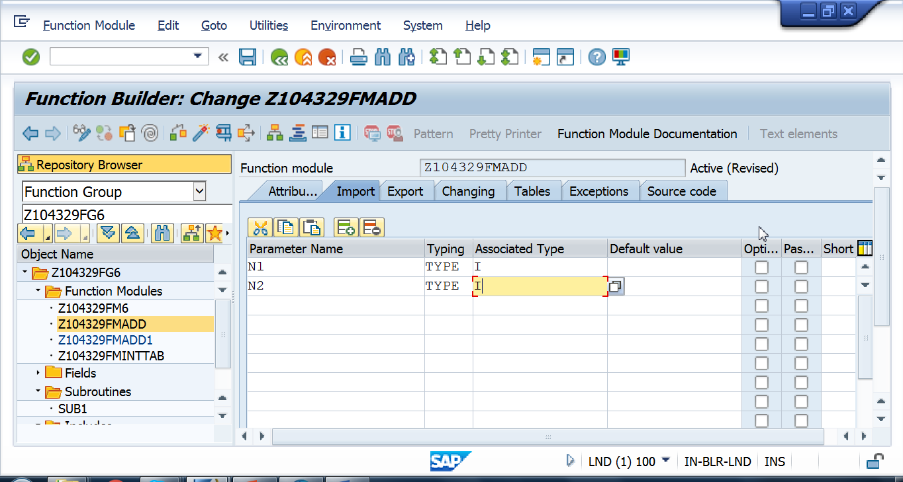

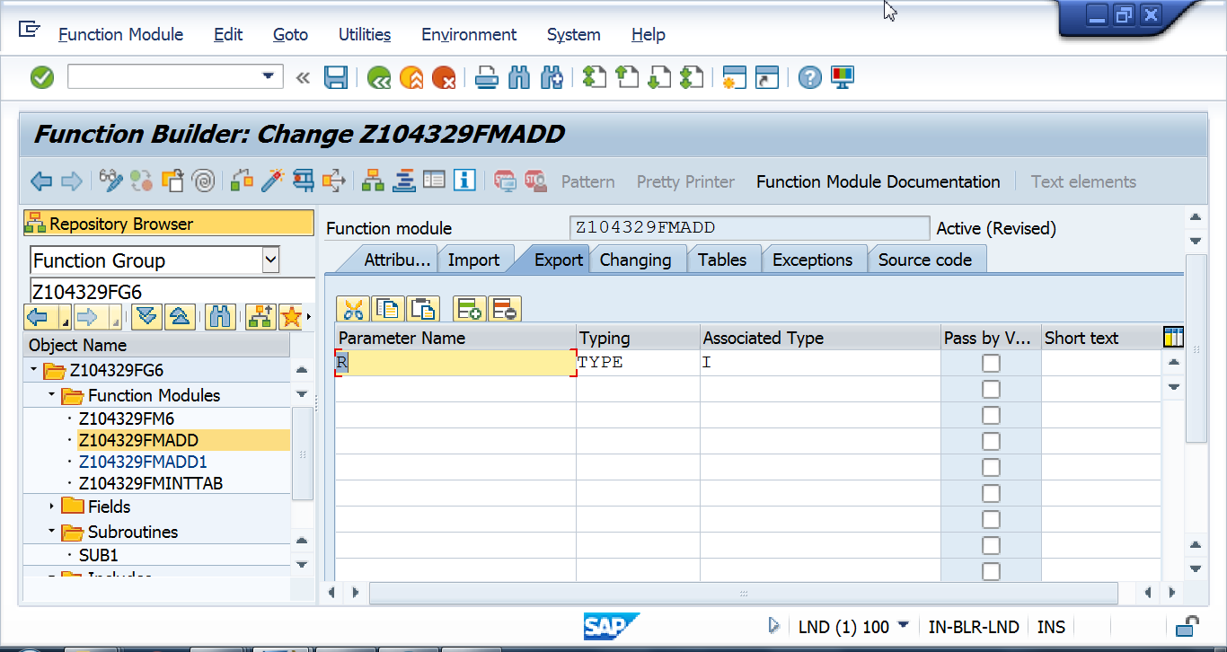

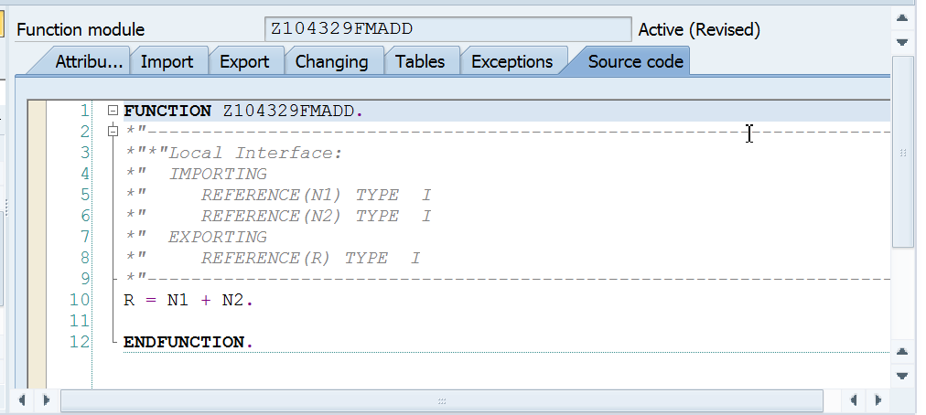

CALL From Se38 program.

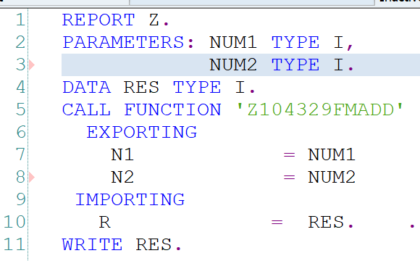

To do by participants: In the FM pass R by value and observe the result in SE38 pgm.

Observe below screenshot.

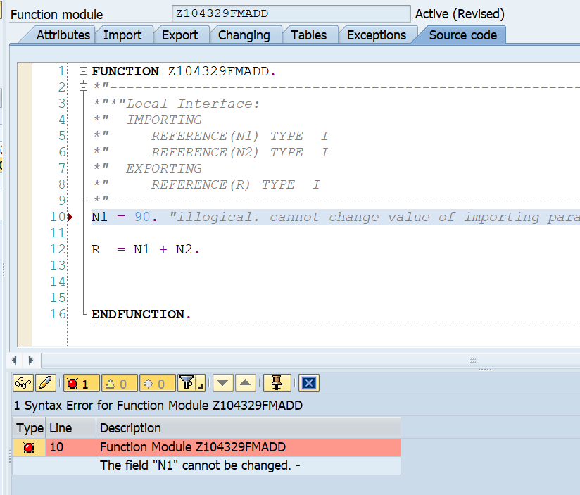

REPORT Z.  
PARAMETERS: NUM1 TYPE I DEFAULT 10,  
            NUM2 TYPE I DEFAULT 20.  
DATA RES TYPE I.  
  
  
CALL FUNCTION 'Z104329FMADD'  
  EXPORTING  
    N1 = NUM1  
    N2 = NUM2  
  IMPORTING  
    R  = RES.  
  
WRITE:/'Res in calling program' ,RES.